ANNEXURE - V

Indian Institute of Technology Bhubaneswar

INVENTION AND TECHNOLOGY DISCLOSURE FORM

Title of the invention: Novel Concrete Composition for Impact Energy Dissipating Crash Barriers.

Brief description of the invention: (How does this invention relate to new processes, systems, machines, compositions of matter, etc? Please cover the following points:)

The present invention relates to the development of a novel impact-dissipating, lightweight structural concrete composition and a crash barrier system incorporating sintered fly ash aggregates, supplementary cementitious materials, and hooked-end steel fibers for highway safety applications.
Conventional reinforced concrete crash barriers are widely used for their high durability and low maintenance requirements. However, their excessive rigidity transmits large impact forces to colliding vehicles, thereby increasing occupant deceleration and the severity of injuries during accidents. Furthermore, conventional concrete barriers are susceptible to brittle failure and fragmentation under severe impact loading, generating high-velocity debris that poses secondary hazards to road users.
The present invention addresses these limitations by developing a lightweight, fiber-reinforced concrete material with enhanced energy dissipation and controlled failure characteristics. The invention comprises a concrete composition containing:
- Ordinary Portland Cement (OPC) as the primary binder;
- Ground Granulated Blast Furnace Slag (GGBS) as a supplementary cementitious material;
- Sintered Fly Ash Aggregate (SFA) as a replacement for conventional coarse aggregate;
- Hooked-end steel fibers incorporated in varying proportions to improve ductility and impact resistance;
- Fine aggregates, water, and chemical admixtures to achieve the required workability and structural performance.
The incorporation of sintered fly ash aggregates significantly reduces concrete density, thereby decreasing the self-weight of crash barriers and improving their deformability under impact loading. The porous internal structure of the lightweight aggregates contributes to additional energy dissipation through localised crushing and internal damping mechanisms.
The addition of hooked-end steel fibers enhances crack-bridging capability, tensile strength, post-cracking behaviour, and resistance to fragmentation. During impact loading, the fibers undergo progressive debonding and pull-out, thereby dissipating substantial amounts of energy and thus decreasing the chances of catastrophic failure.
The synergistic interaction between lightweight aggregates and steel fibers results in a material system exhibiting:
- Reduced density while maintaining structural-grade compressive strength;
- Enhanced tensile and impact resistance;
- Increased deformation capacity and ductility;
- Reduced crack propagation and fragmentation;
- Lower force transmission and occupant deceleration during vehicular collisions;
- Improved residual integrity following repeated impacts.
Experimental investigations have demonstrated that the developed material exhibits substantially greater impact energy absorption and post-cracking resistance than conventional normal-weight concrete, while meeting the strength requirements prescribed for highway crash barrier applications. The invention further promotes the sustainable utilisation of industrial by-products such as fly ash and blast-furnace slag, thereby reducing environmental burdens associated with waste disposal and excessive consumption of natural aggregates. The developed material, thus, may be used in:
- Highway median barriers;
- Bridge crash barriers;
- Roadside protective barriers;
- Precast impact-dissipating elements;
- Airport safety barriers;
- Protective and military structures subjected to dynamic loading.
Accordingly, the invention provides a sustainable, lightweight, ductile, and impact-resistant alternative to conventional concrete barrier materials and offers significant potential for improving transportation safety infrastructure.

- State of prior art:
- Prevailing state of the art?
Presently, roadside crash barriers are generally classified into:
- Flexible barriers (cable barriers)
- Semi-rigid barriers (steel W-beam guardrails)
- Rigid barriers (reinforced concrete barriers).
Among these, reinforced concrete barriers are widely adopted owing to their durability, low maintenance requirements and long service life. However, conventional reinforced concrete barriers exhibit high stiffness and low deformability, thereby transmitting significant impact forces to vehicles and occupants during collisions. Several researchers have attempted to improve crash barrier performance through:
- Rubberised concrete,
- Ultra-high-performance concrete,
- Segmented barriers,
- Steel-wood hybrid barriers,
- Fiber reinforced concrete systems.
However, these systems still suffer from a few major drawbacks, which include:
- High cost,
- Corrosion susceptibility,
- Fabrication complexity,
- Poor sustainability,
- Inadequate energy dissipation.
Furthermore, no commercially adopted crash barrier material presently provides an optimum combination of:
- Low density,
- High impact resistance,
- Enhanced ductility,
- Reduced fragmentation,
- Sustainable material utilisation,
- Structural grade strength.
- Light in weight
Hence, there is a need for a novel crash barrier material that offers improved impact performance while maintaining structural integrity and sustainability.

- Literature search relating to this invention? (Please include copies of any resulting documentation.)
The literature review indicates:
- Studies on steel fiber reinforced lightweight concrete exist.
- Studies on sintered fly ash aggregate concrete exist.
- Studies on alternative crash barrier materials exist.
- Studies on fiber-reinforced rubberised concrete barriers exist.
However, no literature has been identified describing the use of steel fiber-reinforced sintered fly ash lightweight aggregate concrete specifically developed for crash barrier applications, with enhanced impact energy absorption and reduced fragmentation. The literature survey, therefore, indicates a significant research gap and supports the novelty of the proposed invention.
The patent search from Google patents, InPASS, and Espacenet are enclosed with this document.

  - Importance of the proposed project in the context of current status (Maximum 1 page)
Road traffic accidents remain a major cause of fatalities worldwide. In India alone, 56 accidents and 20 deaths every hour in country was associated with road accident in 2024. Although, crash barrier associated data is not available explicitly in India, globally around 1-3% of total crash are associated with crash barrier collision and fatality. Existing rigid concrete crash barriers, although structurally durable, frequently transmit high impact forces to vehicles and occupants due to their excessive stiffness. Moreover, brittle fracture and fragmentation of conventional concrete barriers may create secondary hazards for road users during and after collisions. Further, these crash barriers are extremely heavy posing significant transportation and operational challenges. Simultaneously, the rapid increase in the usage of natural aggregate resources and the accumulation of industrial wastes, such as fly ash, has created serious environmental concerns. Globally, the demand for construction aggregate is expected to range between 55 to 86 billion tons per year, where its extraction is expected to significantly harm the environment. In this regard, exploring alternative for natural aggregate is need of an hour to reduce the environmental impact and increase the overall sustainability index of the construction market.
In this line, the present invention addresses both transportation safety and sustainability challenges by developing a novel lightweight fiber-reinforced concrete material. The proposed invention utilises sintered fly ash aggregate produced from industrial waste, GGBS, hooked-end steel fibers, to produce a structural lightweight concrete exhibiting lower density, superior impact resistance, enhanced ductility, reduced fragmentation, and improved post-impact integrity. With the addition of the sintered lightweight aggregate, the crash barriers will have reduced mass compared to conventional natural-aggregate crash barriers, thereby reducing the transportation and operational expenses and dead load on the substructure.
The technology possesses significant potential for application in highways, bridges, medians, airport barriers, and protective infrastructure. The invention aligns with national initiatives promoting sustainable infrastructure, circular economy, industrial waste utilisation, and improved transportation safety. Considering the rapid expansion of highway infrastructure in India and globally, the invention possesses substantial commercial and societal importance.

- Prior art/patent search relating to this invention? (Please include copies of any resulting documentation.)

A preliminary patent search was carried out using Google Patents, Espacenet, Indian Patent Advanced Search System (InPASS).
Keywords used include:
- Crash barrier concrete,
- Impact-resistant lightweight concrete,
- Steel fiber concrete barrier,
- Lightweight aggregate concrete barrier,
- Sintered fly ash aggregate concrete,
- Energy-absorbing barrier materials.
The search revealed patents specifically relating to:
- Concrete crash barriers,
- Fiber-reinforced concrete,
- Lightweight aggregate concrete,
- Impact-resistant concrete systems.
However, no prior patent was identified that discloses a structural lightweight concrete composition comprising sintered fly ash aggregates, supplementary cementitious materials and hooked-end steel fibers specifically designed for crash barrier applications exhibiting enhanced impact energy absorption, controlled fragmentation and reduced force-momentum transmission. Further professional patentability searches may be undertaken before filing.

The patent search from Google patents, InPASS, and Espacenet are enclosed with this document.

(b) Description: (Describe the invention so that other Institute faculty who are knowledgeable in the field can evaluate its technical and commercial merits.)
The invention relates to a novel impact-dissipating structural lightweight concrete composition and crash barrier comprising:
- Ordinary Portland Cement
- Ground Granulated Blast Furnace Slag (GGBS)
- Fine aggregate
- Sintered fly ash lightweight aggregate
- Hooked-end steel fibers
The material exhibits:
- Structural densities below 2000 kg/m³ indicating light-in-weight compared to conventional aggregate crash barriers
- Compressive strength exceeding the M40 requirement, which is the specified value by many transportation agencies, including India
- Exceptionally high impact dissipation, which was quantified using an impact test
- Enhanced ductility, which was quantified by measuring deflections after impact
- Reduced fragmentation, which was observed after the impact test
- Controlled post-cracking behaviour.
The invention exploits the porous nature of sintered lightweight aggregate to absorb impact energy by undergoing crushing at impact, thereby reducing momentum transfer to vehicle occupants. The energy imparted by the colliding object is utilized in crushing the lightweight aggregates, thus decreasing the momentum transfer for the vehicle and its occupants. Further, the hooked-end steel fibers act as a crack-bridging agent to hold the concrete mass together allowing controlled deformation rather than a brittle and sudden failure. Experimental investigations demonstrated improvements in impact energy absorption by several orders of magnitude over conventional concrete mixtures. The laboratory-scale experiments were further validated by fabricating 1:3-scale models of concrete crash barriers in accordance with international specifications. The sintered lightweight aggregate crash barrier sustained almost twice as many impacts as the conventional rigid concrete crash barrier, demonstrating better endurance under impact loading. Although the initial cost of the sintered lightweight aggregate concrete crash barrier is higher than that of conventional concrete, its cost-to-energy-absorption ratio is almost 16 times lower. This means that the cost per impact is much lower for sintered lightweight aggregate concrete, as it is expected to result in fewer fatal accidents and, hence, lower property damage.

(c) Novelty: (Highlight the features described above that make the invention novel.)
The novelty of the present invention lies in the development of an impact energy-dissipating, lightweight structural concrete composition and a crash barrier system incorporating sintered fly ash aggregates, supplementary cementitious materials, and hooked-end steel fibers, specifically engineered for highway safety applications. The following aspects constitute the novelty of the invention:
  - Novel Application of Sintered Fly Ash Aggregate for Crash Barriers: Although sintered fly ash aggregates have been investigated for lightweight structural concrete applications, their utilisation as a primary aggregate system in vehicular crash barriers has not been reported. The present invention introduces SFA-based lightweight concrete as an energy-absorbing material for crash barriers, thereby extending its application into transportation safety infrastructure.
  - Novel Material Combination: The invention provides a unique combination of Ordinary Portland Cement (OPC), Ground Granulated Blast-Furnace Slag (GGBS), Sintered Fly Ash Aggregate (SFA), Hooked-end steel fibers, and chemical admixtures to produce lightweight concrete with superior impact resistance and ductility. No prior literature or patent has been identified disclosing this specific material combination for crash barrier applications. Technically, the combination is designed in such a way that sintered fly ash lightweight aggregate functions as an impact energy absorbing media, while the steel fibers improve the overall ductility of the concrete reducing excessive fragmentation of concrete and increasing deformation capacity.
  - Synergistic Energy Dissipation Mechanism: The invention utilises a dual energy dissipation mechanism comprising internal crushing and deformation of porous sintered fly ash aggregates, and fiber bridging, debonding and pull-out mechanisms of hooked-end steel fibers. The combined action of these mechanisms produces substantially enhanced impact energy absorption and post-cracking behaviour that are not achievable with conventional concrete barriers.
  - Simultaneous Achievement of Multiple Performance Objectives: The invention simultaneously achieves Structural-grade compressive strength exceeding requirements for crash barriers, reduced density and self-weight, enhanced tensile strength, superior impact resistance, increased deformation capacity, reduced fragmentation and spalling, improved post-impact integrity. Achieving all of these properties simultaneously within a single concrete system is considered novel.
  - Novel Crash Barrier Material System: Conventional rigid concrete barriers primarily rely on structural strength and rigidity. The present invention introduces a semi-energy-absorbing rigid barrier material in which impact energy is dissipated through controlled deformation and internal material mechanisms while retaining sufficient structural integrity.
  - Sustainable Infrastructure Innovation: The invention additionally provides a sustainable solution by utilising industrial by-products such as fly ash and blast furnace slag, thereby reducing dependence on natural aggregates and minimising environmental impacts associated with industrial waste disposal.
Accordingly, the novelty of the present invention resides not merely in the individual constituent materials but in their unique combination, application, and synergistic interaction, resulting in a lightweight, ductile, impact-dissipating, and sustainable concrete material system specifically developed for crash barrier applications. This integrated material-barrier concept has not been reported in the existing literature or identified in prior patent searches.

(d) Inventiveness: (Are the novel features inventive based on (a) above; and, if so, how?)
The present study possesses significant inventive merit because the developed material system and its application to crash barriers are of a kind not found elsewhere in the existing state of the art. The inventiveness of the proposed invention arises from the following aspects:
- Contradictory Material Composition
Crash barriers generally require high compressive strength, high impact resistance, controlled deformation, reduced fragmentation, and high durability. However, conventional lightweight concrete materials generally exhibit lower stiffness, reduced tensile strength, brittle behaviour, and inferior impact resistance. Consequently, a person skilled in concrete technology would ordinarily not consider lightweight concrete as a suitable material for highway crash barrier applications. However, the present invention unexpectedly demonstrates that through appropriate incorporation of sintered fly ash aggregates, GGBS, and hooked-end steel fibers, structural lightweight concrete can simultaneously achieve structural-grade strength, exceptional impact energy dissipation, superior ductility, and enhanced energy absorption. This combination of properties is non-obvious.
- Synergistic Behaviour of Constituent Materials
The invention does not merely represent an aggregation of known materials. Instead, the invention creates a synergistic interaction among
(a) Sintered Fly Ash Aggregate: providing reduced density, internal damping, and aggregate crushing by impact energy absorption.
(b) Hooked-End Steel Fibers: providing crack bridging, stress redistribution, and fiber pull-out energy dissipation.
(c) GGBS: providing improved matrix densification, enhanced interfacial bonding, and durability enhancement.
The simultaneous interaction of these mechanisms produces impact behaviour substantially superior to that expected from the individual materials alone.
- Impact Behaviour
Experimental investigations demonstrated a several-fold increase in impact energy absorption, a substantial improvement in post-cracking resistance, a significant reduction in fragmentation, and enhanced deformation capacity. The magnitude of these improvements was unexpected and cannot be inferred directly from existing studies on lightweight or fiber-reinforced concrete. The invention, therefore, demonstrates an unexpected technical effect, which strongly supports inventiveness.
- Novel Design Philosophy
Conventional rigid crash barriers rely primarily on high stiffness and minimum deformation. The present invention introduces an entirely different approach wherein controlled deformation, internal material damping, aggregate crushing, and fiber pull-out mechanisms are intentionally utilised to dissipate collision energy.
- Sustainable Infrastructure Innovation
The invention simultaneously addresses two independent engineering problems, transportation safety and industrial waste utilisation. Achieving both objectives within a single material composition system provides additional inventive merit. The developed technology enables large-scale utilisation of fly ash and GGBS while improving highway safety performance.
Accordingly, the invention is considered inventive because a person ordinarily skilled in the art would not reasonably expect that a lightweight concrete system incorporating sintered fly ash aggregates and hooked-end steel fibers could simultaneously provide structural-grade strength, superior impact resistance, controlled deformation, enhanced energy dissipation, reduced fragmentation, and improved crash resistance. The invention, therefore, exhibits significant technical advancement and economic significance over the existing state of the art.

(e) Advantages: (What are the advantages of the described invention over (a) above?)
The present invention offers several significant advantages over conventional reinforced concrete crash barriers and other existing impact-resistant barrier systems.
- Enhanced Impact Energy Absorption: The developed lightweight fiber-reinforced concrete exhibits substantially higher impact energy absorption compared with conventional concrete barriers. The porous structure of sintered fly ash aggregates, together with the crack-bridging and pull-out mechanisms of hooked-end steel fibers, enables efficient dissipation of collision energy. This results in improved crashworthiness and superior resistance against repeated impact loading.
- Reduced Force Transmission to Vehicle Occupants: Unlike conventional rigid concrete barriers that transfer large impact forces directly to colliding vehicles, the proposed material undergoes controlled deformation and dissipates internal energy. Consequently, vehicle acceleration is reduced, occupant injury risk is minimised, and crash severity may be significantly lowered.
- Improved Ductility and Post-Cracking Behaviour: Conventional concrete barriers exhibit brittle behaviour and sudden failure. The incorporation of hooked-end steel fibers significantly improves ductility, toughness, residual load-carrying capacity, and post-cracking integrity. The barrier remains structurally stable even after crack initiation.
- Reduced Fragmentation and Spalling: One of the major drawbacks of existing concrete barriers is the generation of high-velocity concrete fragments during severe impacts. The present invention significantly reduces fragmentation, spalling, and secondary projectile hazards through fiber bridging and controlled crack propagation mechanisms, which improves overall road safety.
- Reduced Self-Weight: Replacing conventional coarse aggregates with sintered fly ash aggregates considerably reduces the density of concrete. The major advantages include lower dead load on bridges, reduced transportation costs, easier handling, reduced foundation requirements, and economical precast construction.
- Structural Grade Strength: Despite its reduced density, the developed material satisfies the compressive strength requirements prescribed for highway crash barriers. Thus, the invention simultaneously provides lightweight characteristics and adequate structural performance. This combination is highly advantageous for infrastructure applications.
- Improved Dynamic Performance: The invention exhibits higher damping capacity, improved deformation characteristics, and greater impact resistance, making it particularly suitable for structures subjected to vehicular impact, repeated dynamic loading, accidental collisions, and protective applications.
- Sustainable Utilisation of Industrial Waste: The invention promotes the large-scale utilisation of fly ash and blast-furnace slag, which are industrial by-products and environmental liabilities. The major advantages include a decrease in landfill, conservation of natural aggregate resources, and reduced environmental pollution.
- Potential Reduction in Lifecycle Costs: Although steel fibers increase initial material costs, the invention may significantly reduce maintenance costs, replacement costs, repair requirements, and traffic interruption costs due to improved durability and impact resistance. This may lead to lower lifecycle costs compared with conventional systems.
- Wide Industrial Applicability: The invention may be utilised in highway median barriers, bridge barriers, airport safety barriers, industrial protection systems, military protective structures, blast-resistant infrastructure, and precast impact-resistant elements.

(f) Testing: (Has the invention been tested experimentally? If so, details of experimental data to be supplied)
Yes. The invention has been experimentally validated through extensive laboratory investigations at the School of Infrastructure, Indian Institute of Technology Bhubaneswar.
The developed material system was evaluated at both the material level and structural level to assess its suitability for crash barrier applications.
  - Development of Concrete Mixtures: Several concrete mixtures were developed, comprising ordinary Portland cement (OPC), ground granulated blast-furnace slag (GGBS), sintered fly ash aggregates (SFA), hooked-end steel fibers, fine aggregates, and a superplasticiser. Steel fiber dosage was varied to determine the optimum composition for impact-resistant applications.
  - Fresh Property Evaluation: The fresh properties experimentally investigated include
(a) Slump Test: To evaluate workability.
(b) Wet Density: To confirm structural lightweight classification.
Experimental results confirmed a significant reduction in density compared with conventional concrete while maintaining adequate workability.
  - Mechanical Property Evaluation: The developed mixtures were subjected to:
- Compressive Strength Test: Conducted in accordance with relevant Indian Standards, the results demonstrated that all optimised mixtures achieved structural-grade compressive strengths satisfying crash barrier requirements.
- Split Tensile Strength Test: The inclusion of hooked-end steel fibers resulted in a substantial enhancement in tensile behaviour and crack resistance.
  - Impact Resistance Evaluation: Repeated impact tests were conducted using beam specimens subjected to drop-weight loading. The following parameters were determined:
- Number of impacts to first crack,
- Number of impacts to ultimate failure,
- Energy absorbed at crack initiation,
- Ultimate impact energy absorption,
- Post-cracking resistance.
The experimental results demonstrated several-fold enhancement in impact resistance compared with conventional concrete.
  - Dynamic Response Evaluation: Acceleration measurements were recorded during impact testing using accelerometers. Signal processing and numerical integration techniques were used to determine the acceleration histories, velocity response, displacement response, and deformation characteristics. The developed lightweight fiber-reinforced mixtures exhibited significantly improved deformation capacity and energy dissipation behaviour.
  - Structural-Level Validation: To simulate realistic field conditions, one-third-scale New Jersey crash barrier models were fabricated using conventional M40 concrete, an optimised lightweight fiber-reinforced concrete. The barrier specimens were subjected to pendulum impact loading. The parameters investigated include crack initiation, failure behaviour, acceleration response, displacement response, fragmentation characteristics, and residual structural integrity. Experimental observations demonstrated improved impact resistance and controlled failure behaviour of the developed barrier system.
  - Sustainability and Economic Assessment: Cost-benefit and energy-efficiency analyses were also conducted. The developed material demonstrated enhanced energy absorption capability, reduced environmental impact through industrial waste utilisation, and potential lifecycle cost benefits.
  - Experimental Data Analysis: Detailed experimental data available include material characterisation data, fresh concrete properties, compressive strength results, tensile strength results, impact resistance data, acceleration-time histories, displacement histories, energy absorption characteristics, crash barrier performance data, failure photographs and observations. The experimental findings confirm the technical feasibility and industrial applicability of the invention. Experimental reports, test data, photographs, and supporting documents can be provided by the inventors upon request.
Accordingly, the invention can be successfully implemented and experimentally validated. The results display that the developed lightweight steel fiber-reinforced sintered fly ash aggregate concrete possesses superior impact resistance, enhanced energy dissipation capability, reduced fragmentation, and adequate structural performance, thereby establishing its suitability for crash barrier and protective infrastructure applications.

Experimental setup and results are shown below

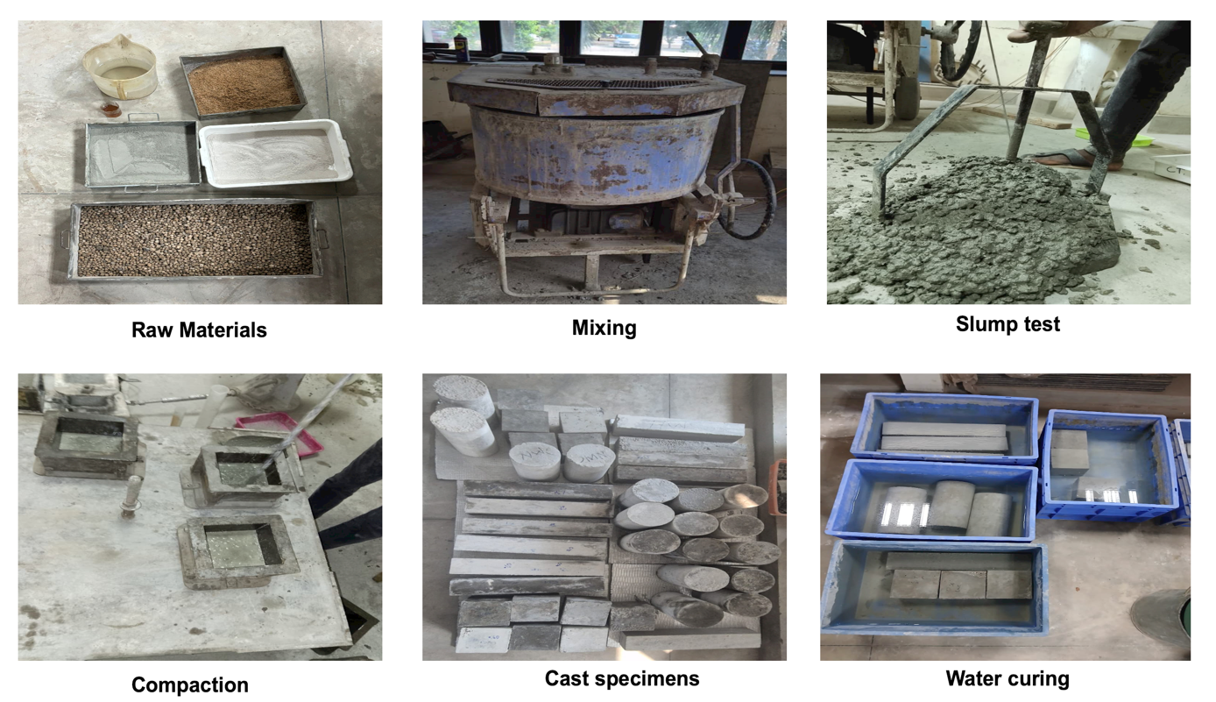
Figure 1. Different Processes adopted to Produced Concrete Mixture

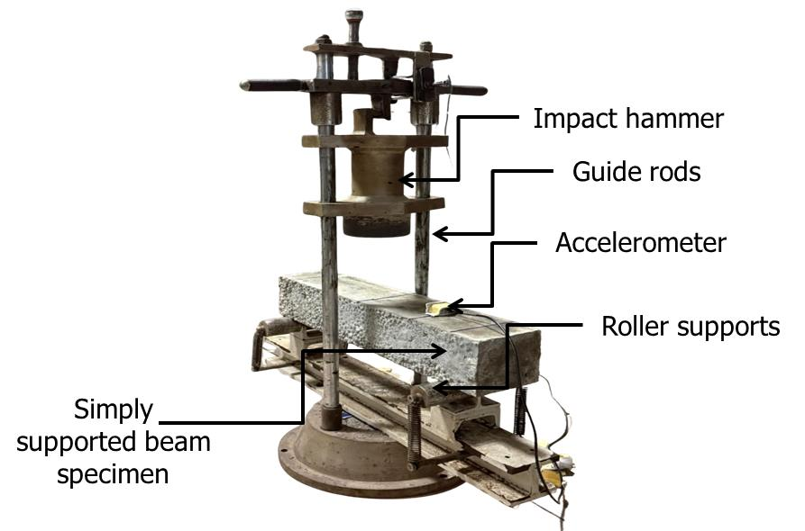
Figure 2. Experimental Setup to Determine Impact Absorption

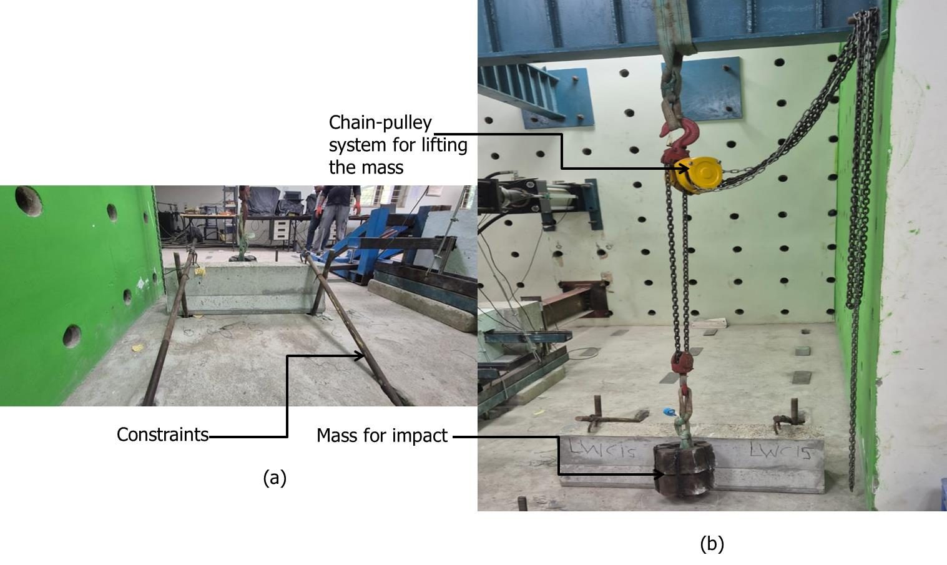
Figure 3. Experimental Setup for Assessing Impact Characteristics of 1:3 Scaled Model of Crash Barrier

Figure 4. Fresh Properties of Concrete Mixtures

Figure 5. Mechanical Properties of Concrete Mixtures
Compressive Strength; (b) Splitting Tensile Strength

Table 1: Impact Energy Absorption of Concrete Prisms

Mix ID | N₁ | N₂ | N₂$-$N₁ | E₁(N-m) | E₂(N-m)
NWC | 2 | 4 | 2 | 26.49 | 52.97
LWC00 | 1 | 2 | 1 | 13.24 | 26.49
LWC05 | 5 | 20 | 15 | 66.22 | 264.87
LWC10 | 15 | 45 | 30 | 198.65 | 595.96
LWC15 | 35 | 221 | 186 | 463.52 | 2927.81

Table 2. Maximum Displacement of Beams after First Impact
Mix Id | Peak Displacement, mm | SD, mm
NWC | 0.28 | 0.005
LWC00 | 0.08 | 0.0163
LWC05 | 0.14 | 0.0144
LWC10 | 0.85 | 0.0173
LWC15 | 0.71 | 0.0686

Table 11: Impact Performance of Crash Barrier Specimens
Mix ID | N₁ | N₂ | E₁ (N-m) | E₂ (N-m)
NWC | 4 | 10 | 549.2 | 1373
LWC15 | 7 | 20 | 961.1 | 2746

(Please use additional sheets to elaborate and to attach sketches, drawings, photographs and other materials that help illustrate the description.)
ANNEXURE - V

Inventors:

Name: Mr. Al-Amir Haruna Saleh | Name: Mr. Pratik Kanungo | Name: Dr. Anush Konayakanahalli Chandrappa | Name: Prof. Dinakar Pasla
Position: Post-Graduate student | Position: Research Scholar | Position: Associate Professor | Position: Professor
Department: School of Infrastructure | Department: School of Infrastructure | Department: School of Infrastructure | Department: School of Infrastructure
Phone: +234-8137781806 | Phone: +91-9668653751 | Phone: +91-6284654627 | Phone: +91-9556297825
E-mail: 24SE06013@iitbbs.ac.in | E-mail: A23CE09018@iitbbs.ac.in | E-mail: akc@iitbbs.ac.in | E-mail: pdinakar@iitbbs.ac.in

(Add further sheets if necessary)

Funding and Support:

Was the invention supported by research grants /contract funds from external sources?
No, the invention was not supported by any research grants or contract funds.

If YES please give details:

- Sponsor/Contractor: Not applicable

- Grant/Contract No.: Not applicable

- Period of Grant/Contract: Not applicable

(f) Was the work done under any other agreement? Give details: No

ANNEXURE – V (contd.)

Was there significant use of IIT Bhubaneswar infrastructure,

as defined in the Intellectual Property Policy of IIT Bhubaneswar?
Yes, the invention was conceived, developed, and experimentally validated using laboratories, equipment, and research facilities available at IIT Bhubaneswar.

Information for the protection of IPR: Conception and Disclosure

(accurate data is required, as prior disclosure may affect the possibility of obtaining patent rights) | Date | References/Comments
Date of conception of the invention. Has this date been documented? If so, where and how? | July 2025 | The conception began with the PG thesis of the first inventor of this invention
Has this been presented at seminars/ discussions other than those that form the requirement for the degree program of the student |  | Not Applicable
Please provide the anticipated date of submission for publication or communication for presentation at a seminar/conference, etc. (should not be earlier than 1 month from this date) | 18 July 2026 | A research article related to the invention has been submitted.
Has the invention been reduced to practice? | April 2026 | The invention has been experimentally validated through laboratory investigations and scaled crash barrier testing

I/we declare that all statements made herein are true to the best of my/our knowledge.

I/we hereby agree to assign all right, title, and interest to IIT Bhubaneswar, agree to execute all documents as requested, assign to IIT Bhubaneswar our rights in any patent filed on this invention, and cooperate in the protection of this invention and its subsequent commercialization. IIT Bhubaneswar will share any royalty income derived from the invention with the inventor(s) in accordance with the IPR policy in force.

 | 16/07/2026 | School of Infrastructure, IIT Bhubaneswar, Khordha, Odisha, 752050
Inventor’s signature | Date | Place
Anush K Chandrappa | 16/07/2026 | School of Infrastructure, IIT Bhubaneswar, Khordha, Odisha, 752050
Inventor’s signature | Date | Place
 | 16/07/2026 | School of Infrastructure, IIT Bhubaneswar, Khordha, Odisha, 752050
Inventor’s signature | Date | Place
Dinakar Pasla | 16/07/2026 | School of Infrastructure, IIT Bhubaneswar, Khordha, Odisha, 752050
Inventor’s signature | Date | Place

ANNEXURE – V (contd)
Notes:

The Invention and Technology Disclosure form must be submitted for each potentially patentable invention that has been conceived or reduced to practice with:
- significant use of Institute Resources
or (ii) sponsored research grants and contracts

This is a legally important document as it:

- Provides the basis for a determination of patentability and for drafting a patent application
or
- Is vital to establish a claim in cases where the invention is at the conception stage, and the inventors wish to enter into an agreement with third parties to obtain support for reduction to practice and/or further development prior to patenting

Please prepare the document with due care.

A patentable invention must not be obvious to a person with average skills in that particular technology. In addition, it must not have been described in a printed publication or be available in the public domain anywhere prior to filing.

A patent confers the right upon an inventor to commercially exploit an invention for a limited period of time. Patents can be lost through disclosure of an invention's details to the public before filing a patent application; they are thus not automatic rights, unlike copyright. To obtain a patent, the proposed invention should be novel (not published elsewhere), inventive (not obvious to persons familiar with the state of the art) and industrially applicable (should have utility). Once the patent is sealed, the patentee can sue for damages anyone who attempts to exploit the patented invention without the consent of the patentee.

Examples of patentable innovations are provided in the IPR policy document. If for some reason patenting cannot be resorted to for an innovation, it can be protected to a limited extent by restricting the publication of information about it (secrecy).

Please submit the completed disclosure form to:

Professor-in-Charge (IPR)
IIT Bhubaneswar

